 |  |  |  | Current date
To
Howden (UK), Medical Professional Liability department
Via Sure International Underwriters Insurance Agency (2013) Ltd
By e-mail (Zeev@Sure.co.il)
Dear Zeev,
 |  | Re: | Insurer name ________________
 |  |  | LineSlip No. _________________
 |  |  | Unique Market Ref: _____________
 |  |  | Insured: _________________
 |  |  | Plaintiff: ___________________
 |  |  | ===========================

Previous Reports:
Report 1 - | ______________________.
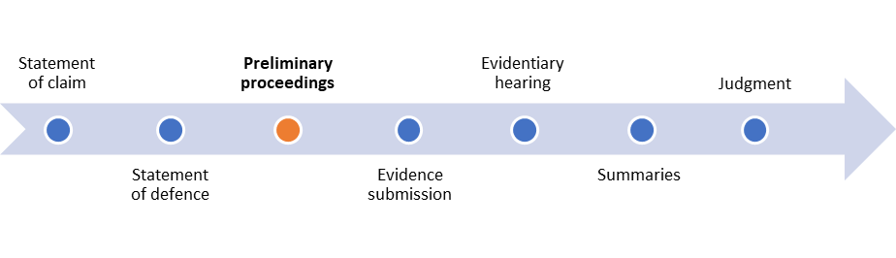
Update
Txt

Header 2
We are at your disposal for any questions and explanations.

